Bahria University,

Karachi Campus



LAB EXPERIMENT NO.

_______10_______

LIST OF TASKS

|  |  |
| --- | --- |
| TASK NO | OBJECTIVE |
| 1 | **Write a node js program to create a server successfully and print the greeting as the server response message to client.** |
| 2 | **Write a node js program to create a server and read the query string and print the server response by using the object property called "url" which holds the part of the url that comes after the domain name.** |
| 3 | **Write a node js program to create an object of your personal details and with the help of built-in functions, print those details as the server response in the form of string.** |
|  |  |
|  |  |

Submitted On:

__28-12-2022__

(Date: DD/MM/YY)

**LAB # 10**

**Task # 01: Write a node js program to create a server successfully and print the greeting as the server response message to client.**

**Solution:**

const http=require("http");

const server =http.createServer((req,res)=>{

    res.write("Hello from the others sides");

    res.end();

});

server.listen(8000,"127.0.0.1",()=>{

    console.log("listening to the port no 8000");

});

**Output:**

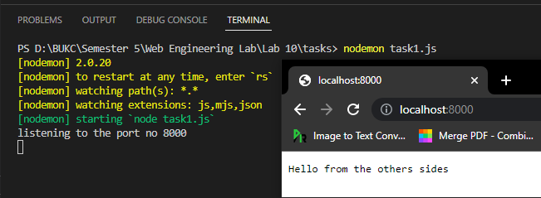

**Task # 02: Write a node js program to create a server and read the query string and print the server response by using the object property called "url" which holds the part of the url that comes after the domain name.**

**Solution:**

const http=require("http");

const server =http.createServer((req,res)=>{

    res.write(req.url);

    res.end();

});

server.listen(8000,"127.0.0.1",()=>{

    console.log("listening to the port no 8000");

});

**Output:**

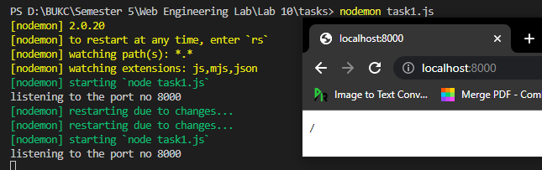

**Task # 03: Write a node js program to create an object of your personal details and with the help of built-in functions, print those details as the server response in the form of string.**

**Solution:**

const http=require("http");

const detail={

    name:"Talha",

    semester:5,

    program:"BSE"}

const server =http.createServer((req,res)=>{

    res.write(JSON.stringify(detail).toString());

    res.end();});

server.listen(8000,"127.0.0.1",()=>{

    console.log("listening to the port no 8000");

});

**Output:**



